**Lab 20**

**Name :-** Aryan Dilipbhai Langhanoja

**Date :-** 10-10-2023

**Enrollment No :-** 92200133030

**CO1: To write, test, and debug simple Python programs**

**CO2: To implement Python programs with conditional, loops and functions**

**Task 1:- Generating and Plotting a Sine Wave Signal**

**Python Code:**

import numpy as np

import matplotlib.pyplot as plt

from scipy import signal as sg

freq = 200000

amp = 5

t = np.linspace(0, 10, 1000)

sig_sine = amp*np.sin(2*np.pi*freq*t)

plt.figure(figsize=(10, 8))

plt.title('Sine Wave', fontsize=20)

plt.plot(t, sig_sine, linewidth=3, label='x(t) = sin(wt)')

plt.xlabel('time', fontsize=15, )

plt.ylabel('Amplitude', fontsize=15)

plt.legend(loc="upper right")

plt.grid()

plt.show()

**Output:**

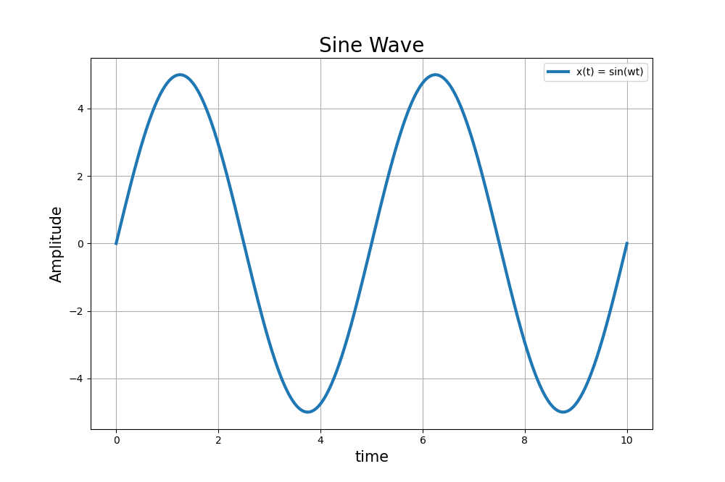

**Task 2:- Generating and Plotting a Square Wave Signal with Python.**

**Python Code:**

import numpy as np

import matplotlib.pyplot as plt

from scipy import signal as sg

freq = 2

amp = 5

t = np.linspace(0, 2, 1000)

sig_square = amp*sg.square(2*np.pi*freq*t, duty=0.5)

plt.figure(figsize=(10, 8))

plt.title('Square Wave', fontsize=20)

plt.plot(t, sig_square, linewidth=3, label='x(t) = Square Wave')

plt.xlabel('time', fontsize=15, )

plt.ylabel('Amplitude', fontsize=15)

plt.legend(loc="upper right")

plt.grid()

plt.show()

**Output:**

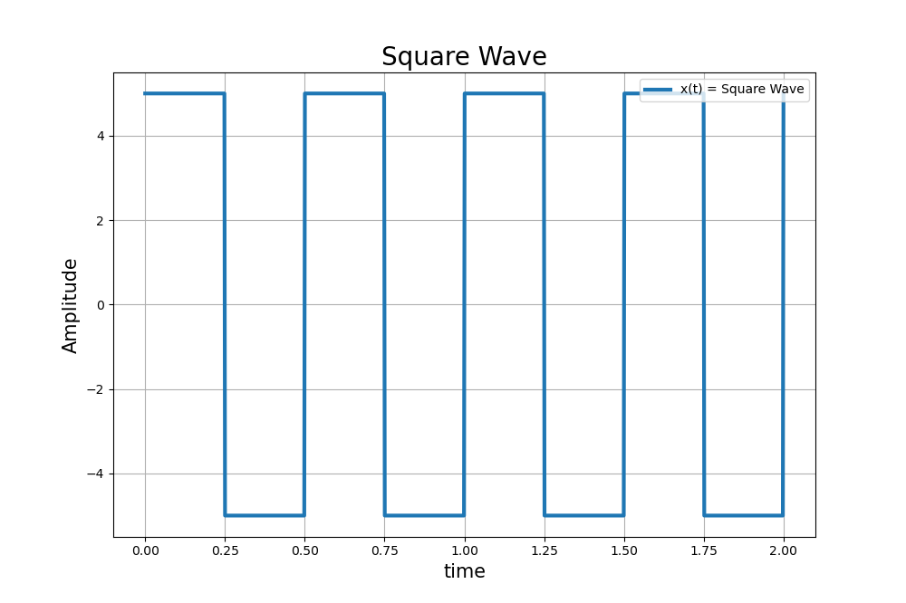

**Task 3:-** **Generating and Plotting a Triangle Waveform in Python with Matplotlib**

**Python Code:**

import numpy as np

import matplotlib.pyplot as plt

from scipy import signal as sg

freq = 2

amp = 5

t = np.linspace(0, 2, 1000)

sig_triangle = amp*sg.sawtooth(2*np.pi*freq*t, width=0.5)

plt.figure(figsize=(10, 4))

plt.title('Triangle Wave', fontsize=20)

plt.plot(t, sig_triangle, linewidth=3, label='x(t) = Tri(wt)')

plt.xlabel('time', fontsize=15, )

plt.ylabel('Amplitude', fontsize=15)

plt.legend(loc="upper right")

plt.grid()

plt.show()

**Output:**

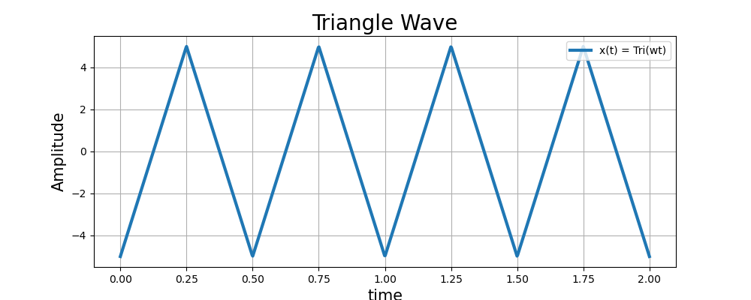

**Task 4:- Plot of Sinc Function with Numpy and Matplotlib**

**Python Code:**

import numpy as np

import matplotlib.pyplot as plt

from scipy import signal as sg

freq = 200000

amp = 5

t = np.linspace(-10, 10, 1000)

sig_sine = amp*np.sinc(t)

plt.figure(figsize=(10, 8))

plt.title('Sine Wave', fontsize=20)

plt.plot(t, sig_sine, linewidth=3, label='x(t) = sin(wt)')

plt.xlabel('time', fontsize=15, )

plt.ylabel('Amplitude', fontsize=15)

plt.legend(loc="upper right")

plt.grid()

plt.show()

**Output:**

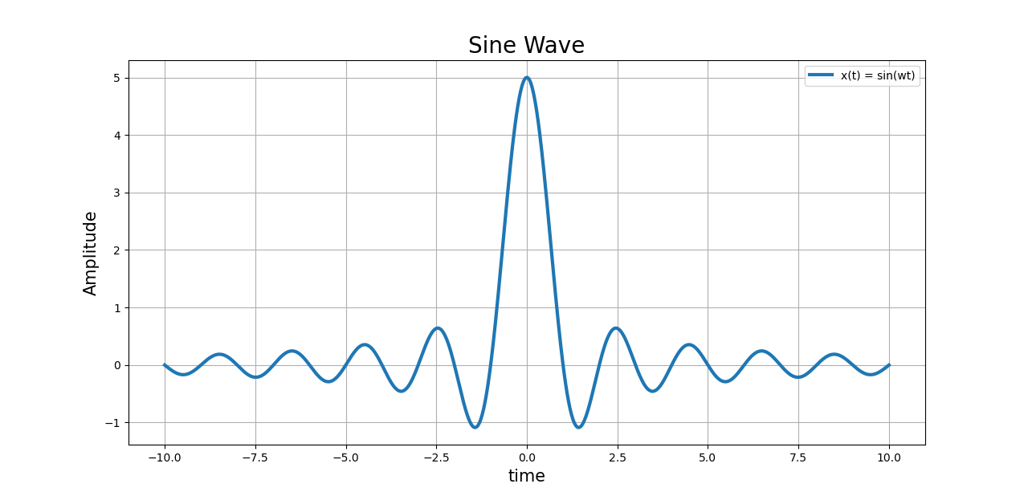

**Task 5:-** **Generating and Plotting a Triangle Waveform in Python with Matplotlib**

**Python Code:**

import numpy as np

import matplotlib.pyplot as plt

from scipy import signal as sg

def p(t):

'''Basic Rectangular Pulse'''

return 1 * (abs(t) < 0.5)

def pt(t):

"""Basic Triangular Pulse"""

return (1 - abs(t)) * (abs(t) < t)

def sgn(t):

"""Sign Function"""

return 1 * (t >= 0) - 1 * (t < 0)

def u(t):

"""Unit Step Signal"""

return 1 * (t >= 0)

functions = [p, pt, sgn, u]

t = np.linspace(-2, 2, 1000)

plt.figure()

for i, function in enumerate(functions, start=1):

plt.subplot(2, 2, i)

plt.plot(t, function(t), '-b')

plt.ylim((-1.1, 1.1))

plt.title(function.__doc__)

plt.tight_layout()

plt.show()

**Output:**

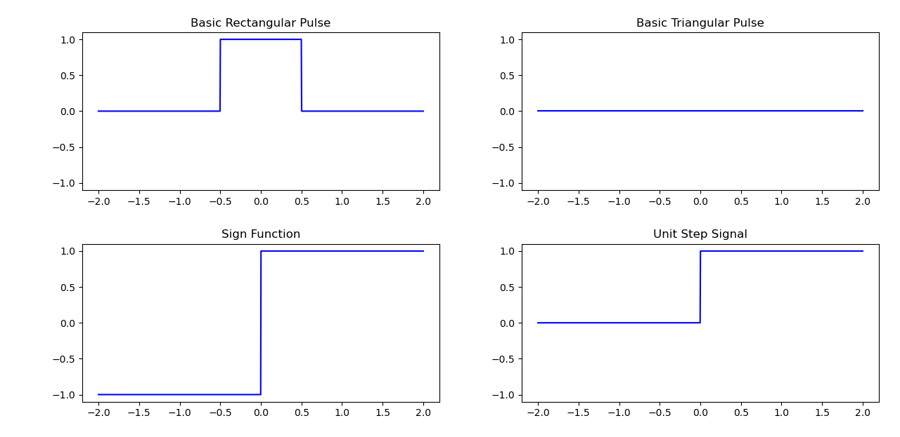

**Post – Lab**

**Task 1:-** **Discrete-Time Ramp Signal Plot**

**Python Code:**

import numpy as np

import matplotlib.pyplot as plt

n = np.arange(-10, 11) # Values from -10 to 10

ramp_signal = n

plt.stem(n, ramp_signal, use_line_collection=True)

plt.title('Discrete-Time Ramp Signal')

plt.xlabel('n (Time)')

plt.ylabel('Amplitude')

plt.grid(True)

plt.show()

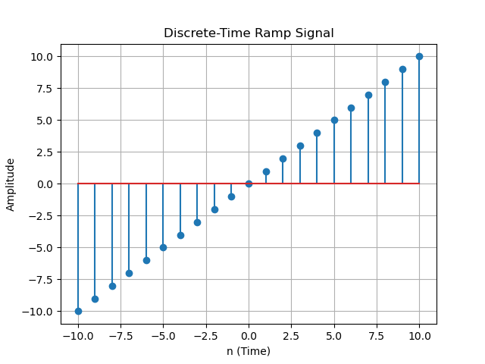**Output:**